Circle detection testing:

The circle detection module is executed after the robot reaches at the entrance point of each room. We performed a test to make sure this module is working as expected. Following is the test process:

The main programme instructs the robot to go to the entrance of the first room, and slowly rotating itself while performing cirlce detection:

As seen from the terminal output, after “robot reaches the designated position”, it started circle detection. The following output (False, False) means neither red circle nor green circle is in sight. When the robot reached the correct angle, it found the red circle and output (‘Red circle detected.’, 23.47), where the number 23.47 means the time elapsed since the script started execution.

The robot then decided to go to the entrance of the second room, which can be seen from the output “Go to (-1.43, 1.15) pose”

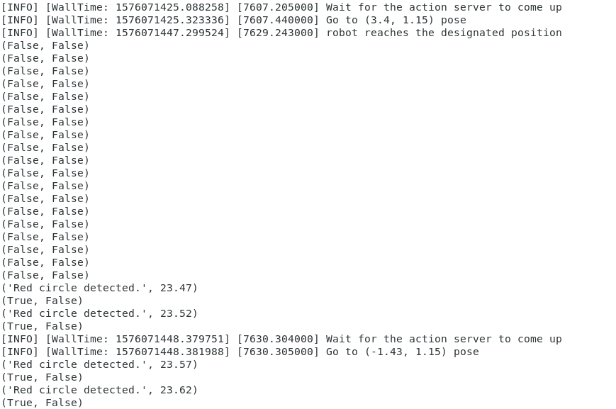

After reaching the entrance of the second room, the robot started rotating while performing circle detection. After a few (False, False), the robot detected the green circle and output (‘Green circle detected.’, 31.62), following is a message “Picture saved as green_circle.png in the same directory as the python script. Absolute path: ../green_circle.png”. The green circle picture is attached below. Then the robot decided to go into the centre point of the second room, which is seen from the following output “Go to (-2.3, 5.63) pose”

